QUESTIONS WITH CORRECT ANSWERS

1. Refer to the exhibits. What is valid text to set the user field in the Database connector configuration to the username value specified in the config.properties file?

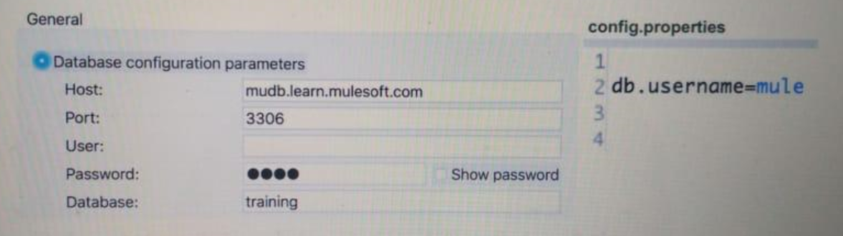

* 1. #[db:username]
  2. ${db.username}
  3. ${db:username}
  4. #[db.username]

1. There are two types of accounts: personal and business. How can an accountType parameter be specified in RAML so <http://localhost/acme/accounts?accountType=personal> is a valid request to the implementation?
   1. uriParameters:

accountType:

enum:

* personal
* business
  1. queryParameters:

accountType:

* personal
* business
  1. uriParameters:

accountType:

* personal
* business
  1. queryParameters:

accountType:

enum:

* personal
* business

[Grab your reader’s attention with a great quote from the document or use this space to emphasize a key point. To place this text box anywhere on the page, just drag it.]

1. Refer to the exhibits. What DataWeave transformation calls the flow with the following input payload?

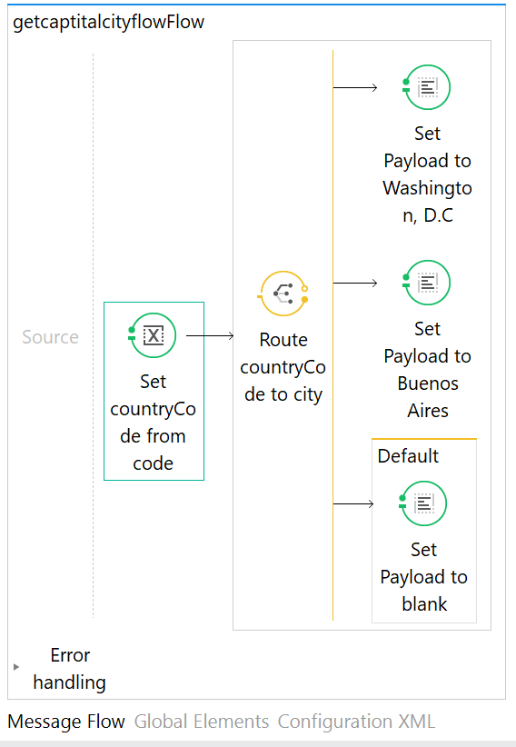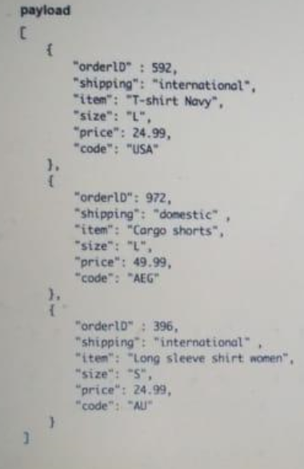

<flow name=*"getCapitalCityFlow"*>

<set-variable variableName=*"countryCode"* value=*"#[payload.code]"* doc:name=*"Set countryCode from code"*/>

<choice doc:name=*"Route countryCode to city"*>

<when expression=*"#[flowVars.countryCode=='USA']"*>

<set-payload value=*"#[ 'Washington, D.C' ]"* doc:name=*"Set payload to Washington D.C"*></set-payload>

</when>

<when expression=*"#[flowVars.countryCode=='AEG']"*>

<set-payload value=*"#[ 'Buenos Aires' ]"* doc:name=*"Set payload to Buenos Aires"*></set-payload>

</when>

<otherwise>

<set-payload value=*"#['']"* doc:name=*"Set payload to blank"*/>

</otherwise>

</choice>

</flow>

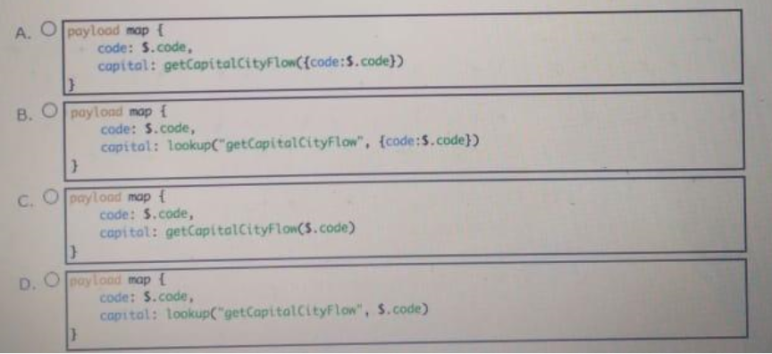

1. Refer to the exhibit. How is the watermark referenced inside the Set Payload transformer?

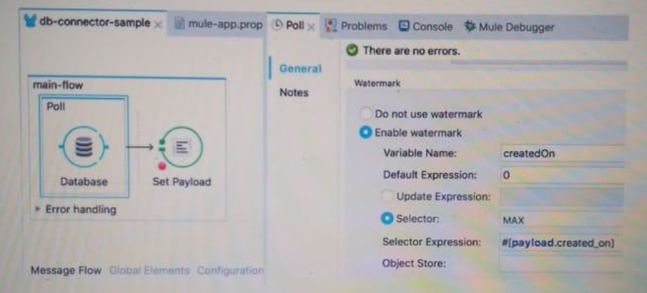

* 1. #[message.inboundProperties.createdOn]
  2. #[payload.createdOn]
  3. #[flowVars.createdOn]
  4. #[message.outboundProperties.createdOn]

1. Refer to the exhibit. In the execution of the Scatter-Gather, the flow1 route completes after 10 seconds and the flow2 route completes after 20 seconds. How many seconds does it take for the Scatter-Gather to complete?

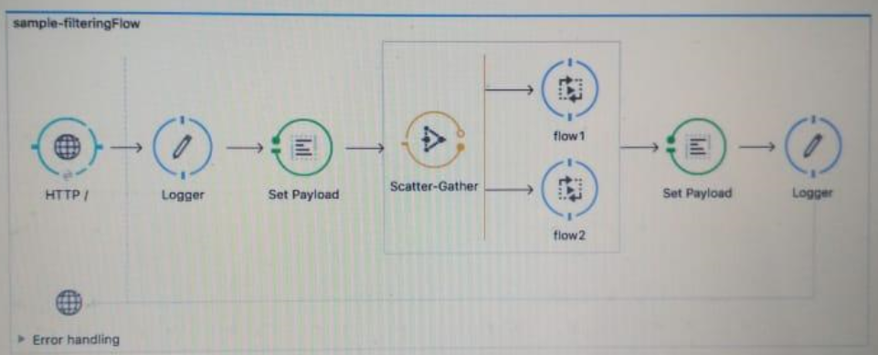

* 1. 0
  2. 10
  3. 20
  4. 30

1. Refer to the exhibit. How many private flows does APIkit generate from the following RAML specification?

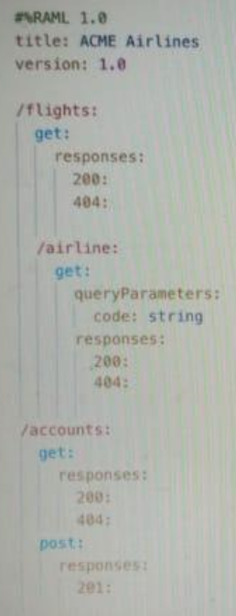

* 1. 2
  2. 3
  3. 4
  4. 7

1. A Database endpoint executes a SELECT statement and gets no results. what payload is returned by this endpoint?
   1. Empty list
   2. Exception
   3. null
   4. 0
2. Refer to the exhibits. what is the expected data that the POST /accounts endpoint expects?

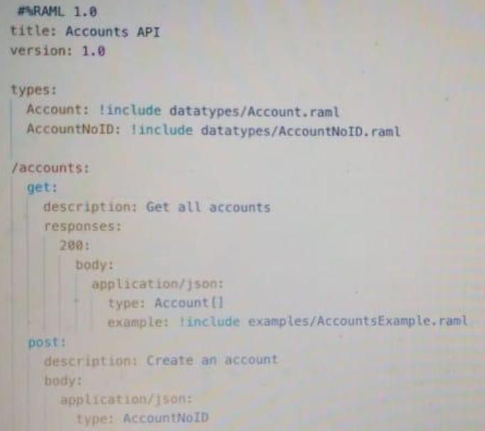

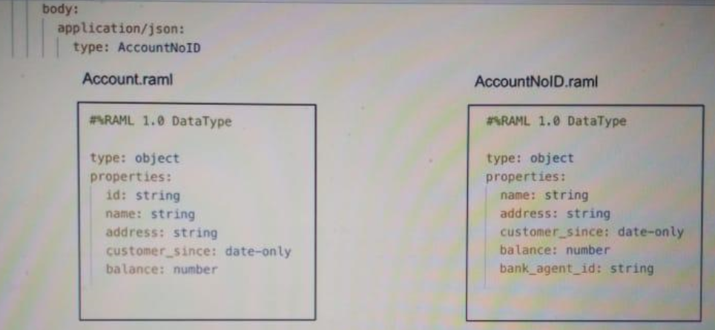

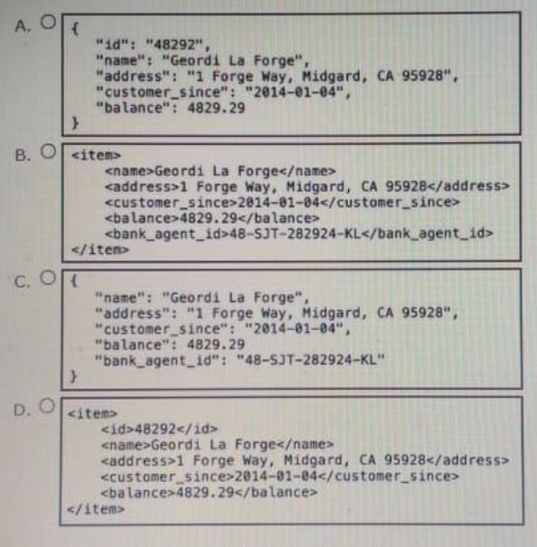

1. In a RAML specification for a banking application, accounts, account_id, and transactions are identified as resources. What resource/method pair retrieves transactions for a specified account_id?
   1. PUT /accounts/{account_id}/transactions/{transaction_id}
   2. GET /accounts/{account_id}/transactions
   3. GET /accounts/account_id
   4. POST /accounts/{account_id}
2. Refer to the exhibits. A Mule application configured to use the globalErrorHandler exception handler.

When the flow is executed, a request is made to a host that is currently offline and Java exception is thrown with the message "Error sending HTTP request to <http://offline.bad:80/> ".

What response is returned to a web client request to postToOfflineHostFlow's Http Listener?

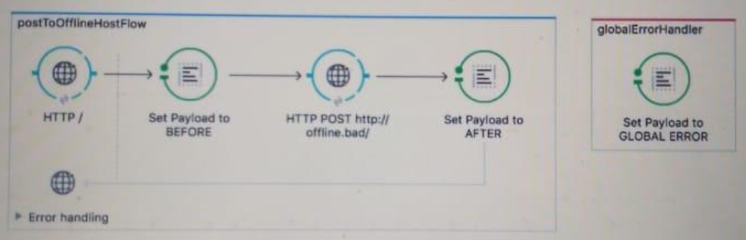

* 1. Error sending HTTP request to <http://offline.bad:80/>
  2. GLOBAL ERROR
  3. BEFORE
  4. AFTER

1. According to MuleSoft's point of view, what is the core activity that enables an application network to emerge in an organization?
   1. Build point-to-point integrations that are referenced in a document library
   2. Enforce and align all data mapping with a master data management system
   3. Build modern APIs that are discoverable and reusable
   4. Build applications that use the same communication protocols to connect to each other
2. What execution model is used by For Each and Batch scopes?
   1. Both are multi-threaded
   2. Both are single-threaded
   3. For Each is single-threaded and Batch is multi-threaded
   4. Batch is single-threaded and For Each is multi-threaded
3. Refer to the exhibit. What DataWeave expression transform the input to the output?

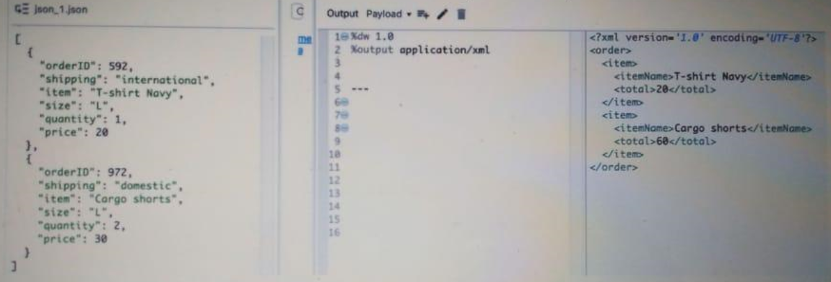

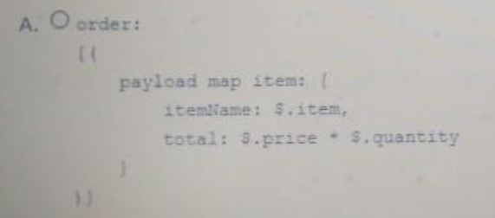

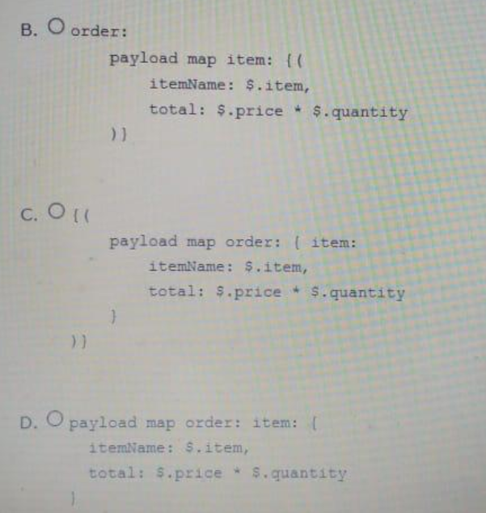

1. OPTION IS CORRECT!!
2. What is the uniform interface used by RESTful web services?
   1. HTTP
   2. JMS
   3. SOAP
   4. RPC
3. Refer to the exhibit. What payload is logged at the end of the mainFlow?

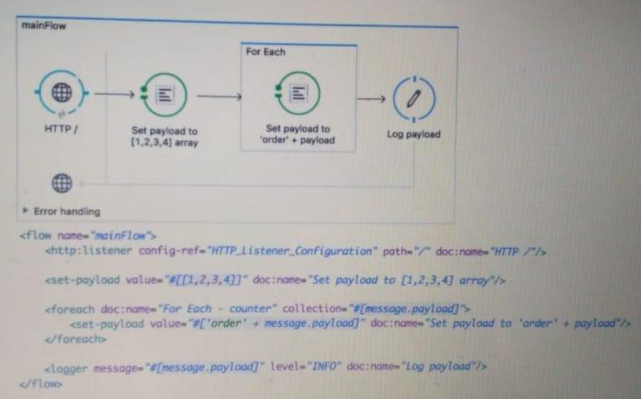

* 1. [order1,order2,order3,order4]
  2. order4
  3. [1,2,3,4]
  4. order4

1. Refer to the exhibit. The validation component in privateFlow throws an exception. What response message is returned to a client request to mainFlow's HTTP Listener?

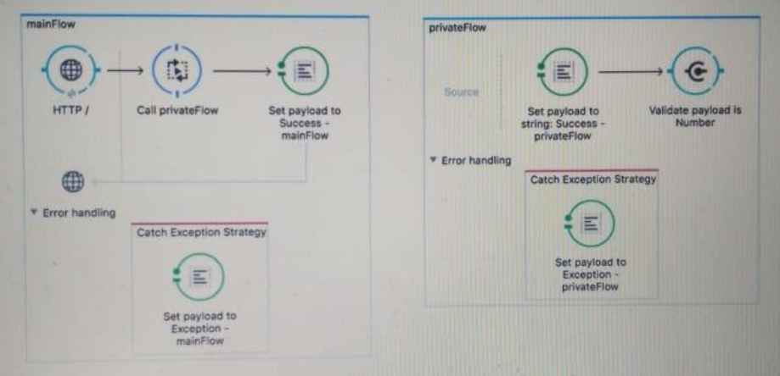

* 1. Success - privateFlow
  2. Success - mainFlow
  3. Exception - privateFlow
  4. Exception - mainFlow

1. What valid RAML retrieves details on a specific order by its orderId as URI parameter?
   1. /orders:

get:

/{orderId}:

* 1. /orders:

/orderId:

get:

* 1. /orders:

/{orderId}:

get:

* 1. /orders:

get:

/orderId:

1. A Transform Message component receives the XML payload:

<order orderId='PO1234'>

<customer>

<customerName>John Doe</customerName>

<country>UK</country>

</customer>

</order>

What is the DataWeave expression to output the orderId string "PO1234"?

* 1. payload.order.orderId
  2. payload.order.@orderId
  3. payload.@orderId
  4. payload.orderId

1. What is the output type of the DataWeave map operator?
   1. String
   2. Array
   3. Object
   4. Map
2. A web client posts a request to <http://localhost:8081?name=john> . what is the correct MEL expression to access the name parameter?
   1. #[message.inboundProperties.'http.query.params'.name]
   2. #[message.outboundProperties.'http.query.params'.name]
   3. #[message.payload.outboundProperties.'http.query.params'.name]
   4. #[message.payload.inboundProperties.'http.query.params'.name]
3. Refer to the exhibit. A payload Filter component processes a message with a non-empty payload. What happens when the payload does not match the Payload Filter type?

<payload-type-filter expectedType=*"java.lang.String"* doc:name=*"Payload is not null"*/>

* 1. It throws a Filter exception
  2. It silently stops processing the message
  3. It calls a compensation flow
  4. It throws a configurable exception

1. Refer to the exhibit. What should be changed to fix the 400 Bad request error?

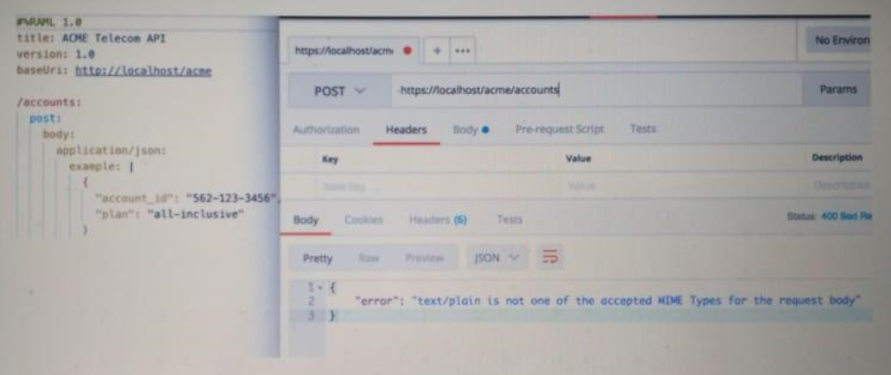

* 1. Set the **response** Content-Type in the RAML specification to text/palin
  2. Set the **request** Content-Type to text/palin
  3. Set the **response** Content-Type header to application/json
  4. Set the **request** Content-Type header to application/json

1. What authentication data is required to configure a Throttling - SLA based policy in API Manager?
   1. OAuth2.0 access token
   2. Username and password
   3. x.509 client certificate and x.509 server certificate
   4. Client id and client secret
2. Refer to the exhibits. What is the expected behavior of this application?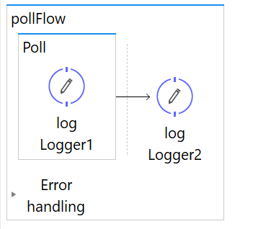

<flow name=*"pollFlow"*>

<poll doc:name=*"Poll"*>

<fixed-frequency-scheduler frequency=*"2000"*/>

<logger message=*"#['LOGGER1']"* level=*"INFO"* doc:name=*"log Logger1"*/>

</poll>

<logger message=*"#['LOGGER2']"* level=*"INFO"* doc:name=*"log Logger2"*/>

</flow>

* 1. An exception will be thrown indicating there is no inbound endpoint as a message source
  2. After 2 seconds, the application will output LOGGER1 and LOGGER2 exactly once
  3. The application will immediately output LOGGER1 and LOGGER2 messages exactly once
  4. The application will continuously output LOGGER1 and LOGGER2 messages every 2 seconds

1. Refer to the exhibits. The parentFlow contains an HTTP request in the middle of the flow. The HTTP Listeners and HTTP Request use default configurations

What values are accessible to the parent Logger at the end of the parentFlow after a web client submits a request to <http://localhost:8081/order?color=red> ?

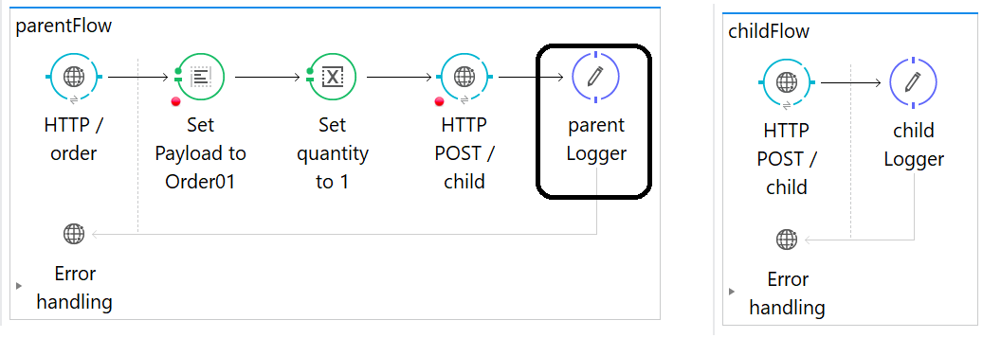

<http:request config-ref=*"HTTP_Request_Configuration"* path=*"/child"* method=*"POST"* doc:name=*"HTTP POST /child"*/>

<logger level=*"INFO"* doc:name=*"parent Logger"*/>

</flow>

<flow name=*"childFlow"*>

<http:listener config-ref=*"HTTP_Listener_Configuration"* path=*"/child"* doc:name=*"HTTP POST /child"* allowedMethods=*"POST"*/>

<logger level=*"INFO"* doc:name=*"child Logger"*/>

</flow>

* 1. payload
  2. payload

quantity var

* 1. payload

color query param

* 1. payload

color query param

quantity var

1. What three layers are part of MuleSoft's definition of the API-led connectivity model?
   1. Client, Proxy, Server
   2. Backend, Mediation, Frontend
   3. System, Process, Experience
   4. Model, View, Controller
2. Refer to the exhibits. A web client calls <http://localhost:8081?fruit=Apple> . What is the payload at the end of the flow?

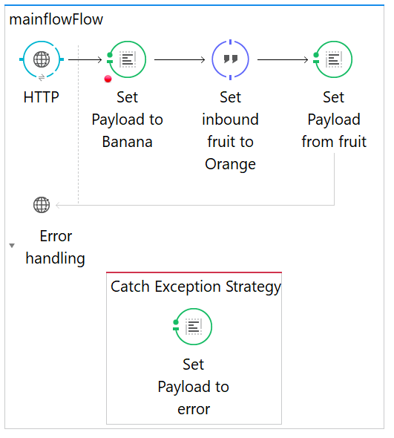

<flow name=*"mainflowFlow"*>

<http:listener config-ref=*"HTTP_Listener_Configuration"* path=*"/"* doc:name=*"HTTP"*/>

<set-payload value=*"#['Banana']"* doc:name=*"Set Payload to Banana"*/>

<expression-component doc:name=*"Set inbound fruit to Orange"*>

<![CDATA[message.inboundProperties.'http.query.params'.fruit='Orange']]>

</expression-component>

<set-payload value=*"#[message.inboundProperties.'http.query.params'.fruit]"* doc:name=*"Set Payload from fruit"*/>

<catch-exception-strategy doc:name=*"Catch Exception Strategy"*>

<set-payload value=*"#['Error']"* doc:name=*"Set Payload to error"*/>

</catch-exception-strategy>

</flow>

* 1. Apple
  2. Error
  3. Banana
  4. Orange

1. Refer to the exhibits. The batch job processors, filters and commit records. what is the expected output from the Logger component when this Mule application runs?

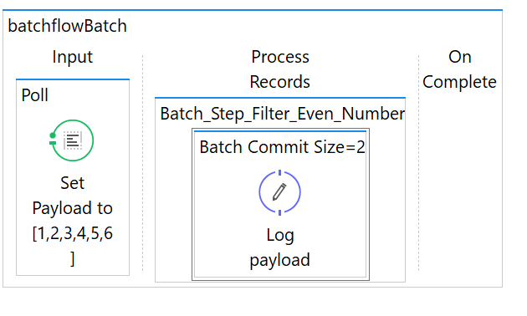

<batch:job name=*"batchflowBatch"*>

<batch:input>

<poll doc:name=*"Poll"*>

<fixed-frequency-scheduler frequency=*"10"* timeUnit=*"SECONDS"*/>

<set-payload value=*"#[[1,2,3,4,5,6]]"* doc:name=*"Set Payload to [1,2,3,4,5,6]"*/>

</poll>

</batch:input>

<batch:process-records>

<batch:step name=*"Batch_Step_Filter_Even_Number"* accept-expression=*"#[payload % 2 == 0]"*>

<batch:commit size=*"2"* doc:name=*"Batch Commit Size=2"*>

<logger message=*"#[payload]"* level=*"INFO"* doc:name=*"Log payload"*/>

</batch:commit>

</batch:step>

</batch:process-records>

</batch:job>

* 1. [2,4,6]
  2. [1,2,3,4,5,6]
  3. [1,2]

[3,4]

[5,6]

* 1. [2,4]

[6]

1. Refer to the exhibit. what is the output payload in the On Complete phase?

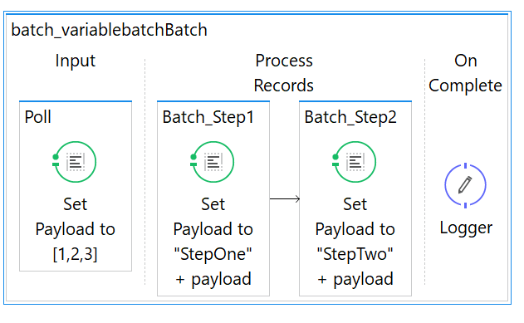

* 1. The records processed by all batch steps: [StepTwoStepOne1, StepTwoStepOne2, StepTwoStepOne3]
  2. The records processed by the last batch step: [StepTwo1,StepTwo2,StepTwo3]
  3. The original payload [1,2,3]
  4. Summary statistics with NO record data

1. Refer to the exhibit. What is the correct syntax to add an employee ID as a URI parameter in the HTTP Listener path?

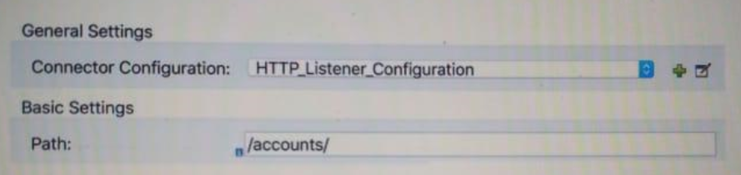

* 1. ${employeeId}
  2. #[employeeId]
  3. {employeeId}
  4. (employeeId)

1. According to MuleSoft's point of view, how does Central IT enable the new IT operating model?
   1. Builds all API implementations and restricts line of business developers from building implementations to save cost and enforce standards
   2. Combines and shares API specifications like a product to drive consumption by line of business developers
   3. Distributes passwords to databases and backend systems to allow direct access by line of business developers to deliver faster
   4. Invests in new cloud technology to enable Central IT to develop complete line of business applications faster.
2. To avoid hard-coding values, a flow uses some property placeholders and the corresponding values are stored in a configuration file.

where does the configuration file's location need to be specified in the Mule application?

* 1. mule-deploy.properties
  2. mule-app.properties
  3. A flow property
  4. A global element

1. A Transform Message component receives the XML payload:

<order orderId='PO1234'>

<customer>

<customerName>Alice Green</customerName>

<country>UK</country>

</customer>

<customer>

<customerName>Bob Brown</customerName>

<country>AU</country>

</customer>

</order>

What is the DataWeave expression to output an array of the two customerName elements?

* 1. payload.order.*customer.customerName
  2. payload.order.customer.customerName
  3. payload.order.customer[].customerName
  4. payload.order.*customer[].customerName

1. Refer to the exhibit. All three of the conditions for the choice router is true. What message processors are executed?

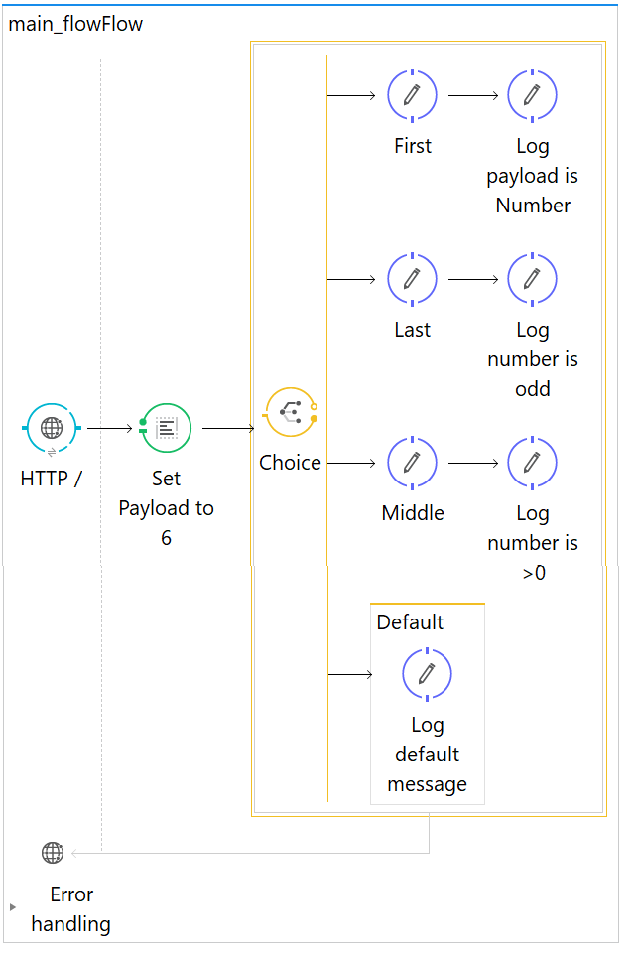

* 1. First
  2. First, Default
  3. First, Middle, Last
  4. First, Middle, Last, Default

1. What path setting is required for an HTTP Listener endpoint to route all requests to an APIkit router?
   1. /*
   2. ALL
   3. /
   4. /{*}
2. Refer to the exhibit. The order.csv file is read, then processed to look up the orders from the database. The mule application is debugged in Anypoint Studio and stops at the breakpoint. What is the payload shown in the debugger at the breakpoint?

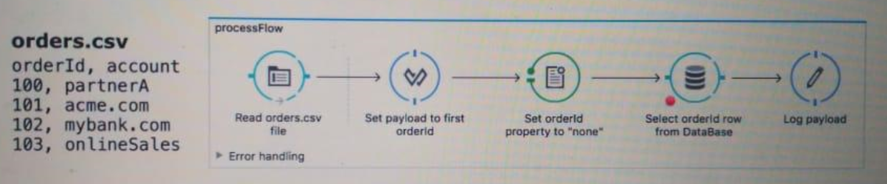

* 1. "none"
  2. The entire CSV file
  3. 100
  4. The database response

1. A Mule application has a single File connector configured. A flow in the Mule application has a File connector endpoint in the message source and another File connector endpoint as a message processor in the flow. What is the behavior of these two components?
   1. The source writes files and the processor reads files
   2. The source reads files and the processor writes files
   3. The source and processor both write files
   4. The source and processor both read files
2. what three elements are used in RAML specifications?
   1. Response
   2. PortType
   3. Service
   4. Resource
   5. Method
3. Refer to the exhibit. What is the output payload?

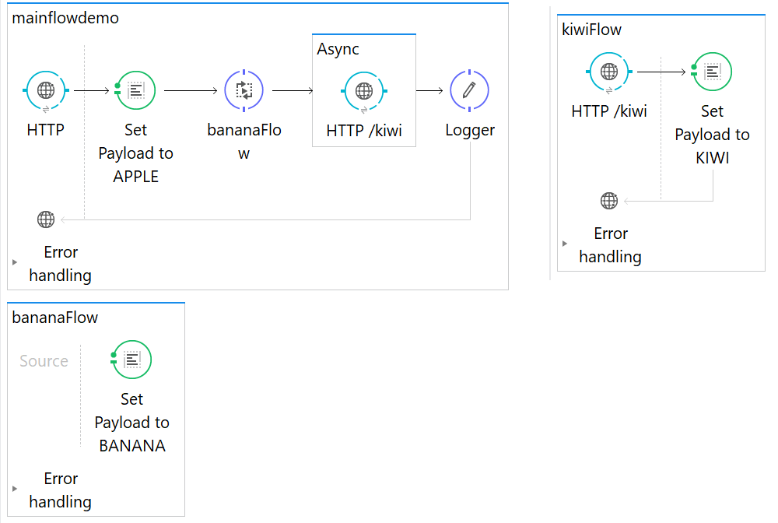

<flow name=*"mainflowdemo"*>

<http:listener config-ref=*"HTTP_Listener_Configuration"* path=*"/"* doc:name=*"HTTP"*/>

<set-payload doc:name=*"Set Payload to APPLE"* value=*"APPLE"*/>

<flow-ref name=*"bananaFlow"* doc:name=*"bananaFlow"*/>

<async doc:name=*"Async"*>

<http:request config-ref=*"HTTP_Request_Configuration"* path=*"/kiwi"* method=*"GET"* doc:name=*"HTTP /kiwi"*/>

</async>

<logger level=*"INFO"* doc:name=*"Logger"*/>

</flow>

<flow name=*"bananaFlow"*>

<set-payload value=*"BANANA"* doc:name=*"Set Payload to BANANA"*/>

</flow>

<flow name=*"kiwiFlow"* processingStrategy=*"synchronous"*>

<http:listener config-ref=*"HTTP_Listener_Configuration"* path=*"/kiwi"* doc:name=*"HTTP /kiwi"*/>

<set-payload value=*"KIWI"* doc:name=*"Set Payload to KIWI"*/>

</flow>

* 1. null
  2. APPLE
  3. KIWI
  4. BANANA

1. Why would a Mule application use the ${http.port} property palceholder for its HTTP Listener port when it is deployed to CloudHub?
   1. Allows Mulesoft support to troubleshoot the application by connecting directly to the HTTP Listener
   2. Allows clients to VPN directly to the application at the Mule application's configured HTTP port
   3. Allows CloudHub to automatically change the HTTP port to allow external clients to connect to the HTTP Listener
   4. Allows CloudHub to automatically register the application with API Manager
2. Refer to the exhibit. What action will resolve the exception?

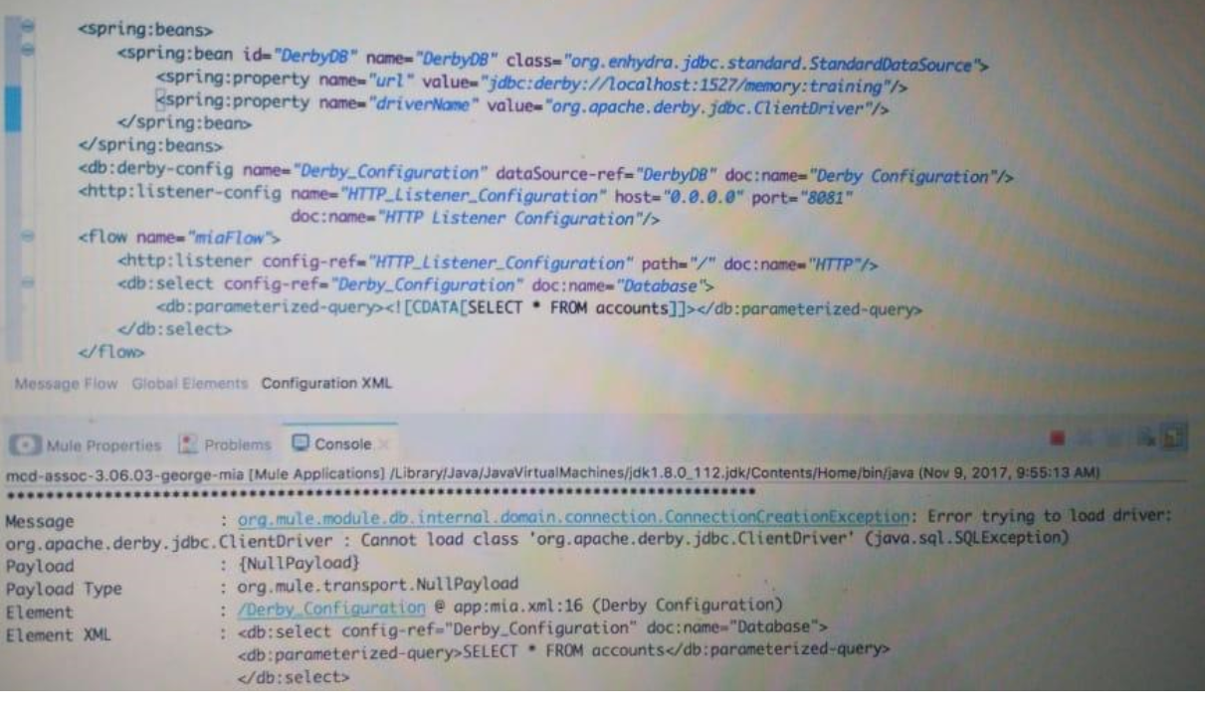

* 1. Add a JDBC driver to the project's build path
  2. Create the accounts table in the database
  3. Ensure the database is accessible
  4. Implement org.apache.derby.jdbc.ClientDriver

1. Refer to the exhibit. A web client makes a request to the postUserFlow's HTTP Listener. The Validation component in hrFlow then throws an exception. What response message is returned to the web client?

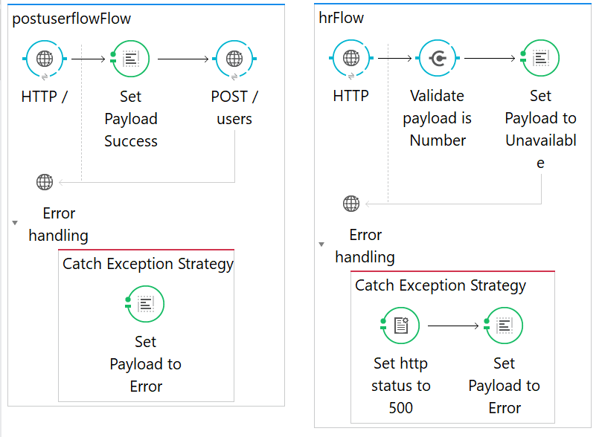

* 1. Success
  2. Unavailable
  3. Boom
  4. Error

1. Refer to the exhibits. How is the userName property passed to the outbound HTTP request?

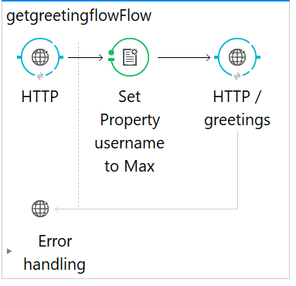

<http:listener-config name=*"HTTP_Listener_Config"* host=*"0.0.0.0"* port=*"8081"* doc:name=*"HTTP Listener Configuration"*/>

<http:request-config name=*"HTTP_Request_Config"* host=*"localhost"* port=*"8081"* doc:name=*"HTTP Request Configuration"*/>

<flow name=*"getgreetingflowFlow"*>

<http:listener config-ref=*"HTTP_Listener_Config"* path=*"/"* doc:name=*"HTTP"*/>

<set-property propertyName=*"userName"* value=*"#['Max']"* doc:name=*"Set Property userName to Max"*/>

<http:request config-ref=*"HTTP_Request_Config"* path=*"/greetings"* method=*"GET"* doc:name=*"HTTP /greetings"*/>

</flow>

* 1. Query parameter
  2. Body
  3. URI parameter
  4. Header

1. A Mule application contains a global exception strategy configured to catch any exceptions.

Where must the global exception strategy be specified so that this global exception strategy catches all errors from flows without their own exception strategies?

* 1. A global element
  2. Nowhere, the global exception strategy is automatically used
  3. The mule-deploy.properties file
  4. A configuration properties file

1. Refer to the exhibits. What is the response to a web client request to <http://localhost:8081> ?

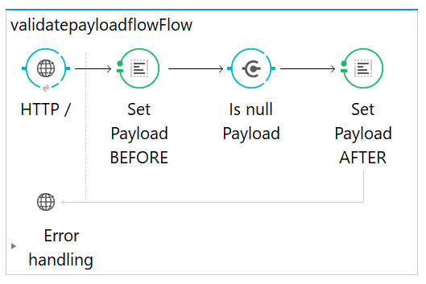

<http:listener-config name=*"HTTP_Listener_Config"* host=*"0.0.0.0"* port=*"8081"* doc:name=*"HTTP Listener Configuration"*/>

<flow name=*"validatepayloadflowFlow"*>

<http:listener config-ref=*"HTTP_Listener_Config"* path=*"/"* doc:name=*"HTTP /"*/>

<set-payload value=*"#['BEFORE']"* doc:name=*"Set Payload BEFORE"*/>

<validation:is-null message=*"#['payload is null']"* value=*"#[payload]"* doc:name=*"Is null Payload"*/>

<set-payload value=*"#['AFTER']"* doc:name=*"Set Payload AFTER"*/>

</flow>

* 1. The string 'BEFORE'
  2. The string 'Payload is null'
  3. null
  4. The string 'AFTER'

1. Refer to the exhibits. What is the root cause of the error?

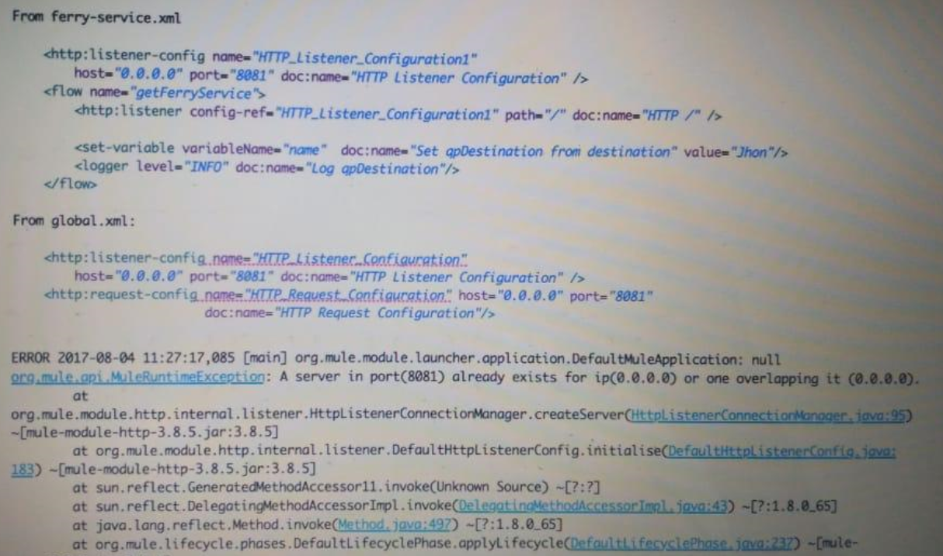

Answer: duplicate configuration of HTTP Listeners

1. Refer to the exhibit. The parentFlow contains a Flow Reference for childFlow.

What values are accessible in childFlow after a web client submits a request to <http://localhost:8081/order?color=red> ?

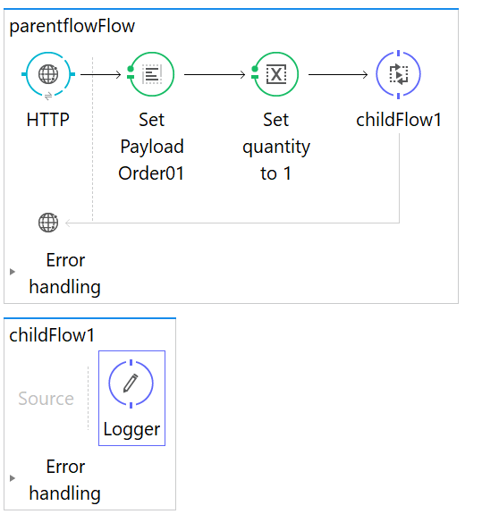

* 1. payload
  2. payload

quantity var

* 1. payload

color query param

* 1. payload

quantity var

color query param

1. Refer to the exhibit. What DataWeave transformation retrieves the current time?

%dw 1.0

%output **application/java**

---

{

"currentTime" : p('currentTime()')

}

%dw 1.0

%output **application/java**

---

{

"currentTime" : lookup("currentTime",null)

}

%dw 1.0

%output **application/java**

---

{

"currentTime" : currentTime()

}

%dw 1.0

%output **application/java**

---

{

"currentTime" : lookup(currentTime())

}

1. Refer to the exhibit. What is the correct way to create a user?

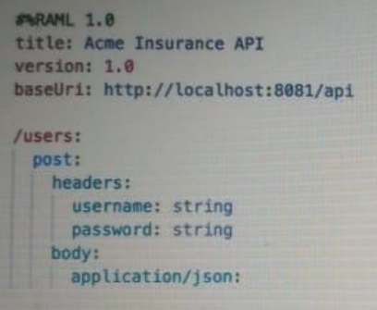

* 1. 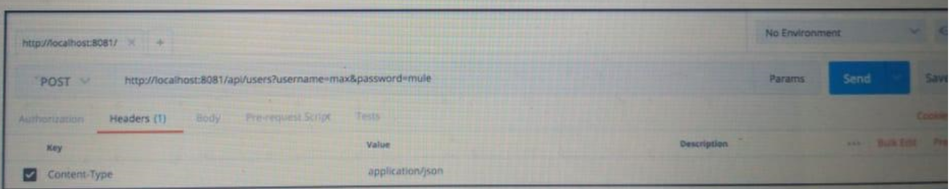
  2. 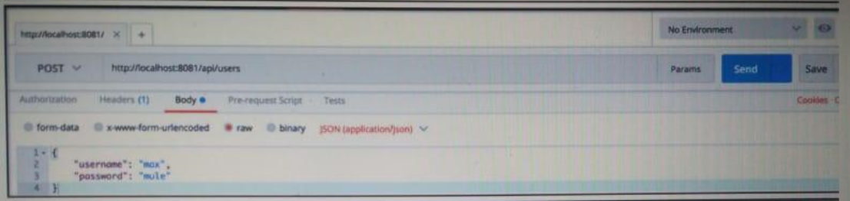
  3. 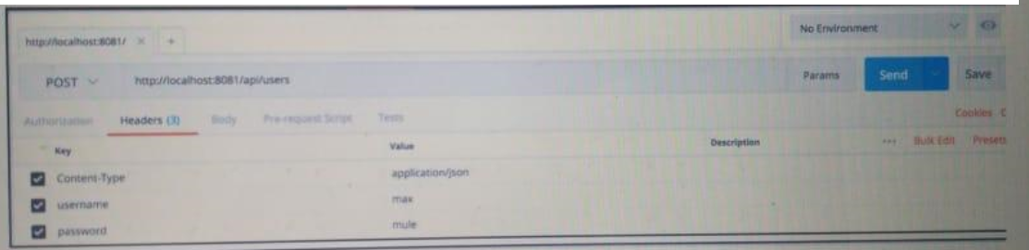
  4. 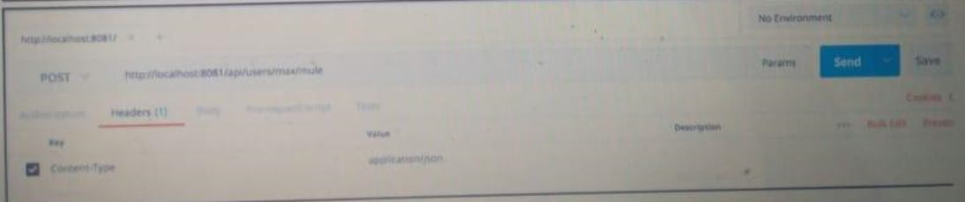

1. Refer to the exhibits. The http:request has failed with Timeout exceeded error. What HTTP Request parameter must be modified to resolve this error?

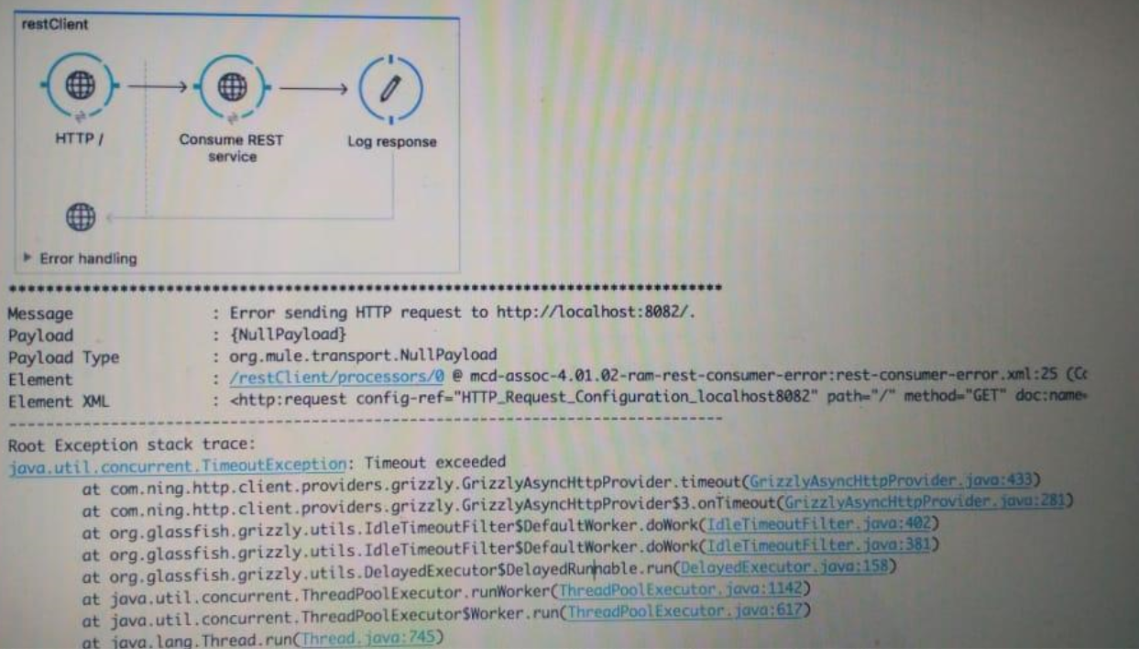

* 1. Response Timeout
  2. Transaction Timeout
  3. Client Certificate Timeout
  4. Connect Idle Timeout

1. Refer to the exhibit. A web client submits a request to <http://localhost:8081> . What is the structure of the playload at the end of the flow?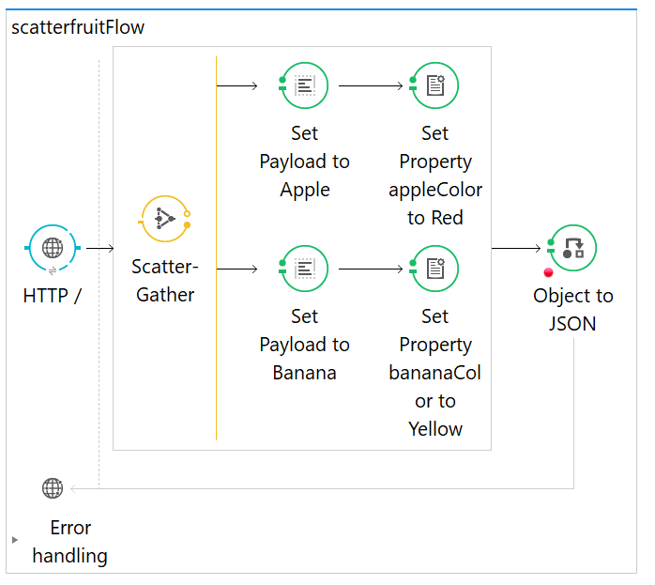
   1. [

{

"inboundProperties" : ....,

"outboundProperties" : ....,

"payload": "Apple,Banana"

}

]

* 1. {

"0" : "Apple",

"1" : "Banana"

}

* 1. [

{

"inboundProperties" : ....,

"outboundProperties" : ....,

"payload": "Banana"

},

{

"inboundProperties" : ....,

"outboundProperties" : ....,

"payload": "Apple"

}

]

* 1. [

"Apple",

"Banana"

]

1. A Mule application is created with an HTTP inbound endpoint defined to receive custName and accountType as query parameters. The accountType is captured using a Set Variable transformer with the same name. What is the correct MEL expression for logging accountType?
   1. #[message.inboundProperties.accountType]
   2. #[message.'http.query.params'.accountType]
   3. #[flowVars.accountType]
   4. #[message.outbountProperties.accountType]
2. Refer to the exhibit. What transformer should be used in the httpFlow so that the fruit value in the request <http://localhost:8081/?fruit=Orange> is accessible in the jmsFlow?

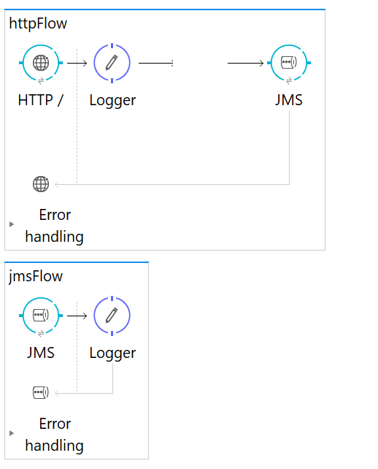

* 1. set-variable
  2. set-property
  3. set-inbound-property
  4. set-record-variable

1. An SLA based policy has been enabled in API Manager. What is the next step to configure the API proxy to enforce the new SLA policy?
   1. Add required headers to the RAML specification and redeploy the new API proxy
   2. Add new property placeholders and redeploy the API proxy
   3. Restart the API proxy to clear the API policy cache
   4. Add new environment variables and restart the API proxy
2. What HTTP method should be used to add a new member to a collection in a RESTful service?
   1. DELETE
   2. POST
   3. PUT
   4. GET
3. Refer to the exhibit. What is the paylaod at the end of the flow?

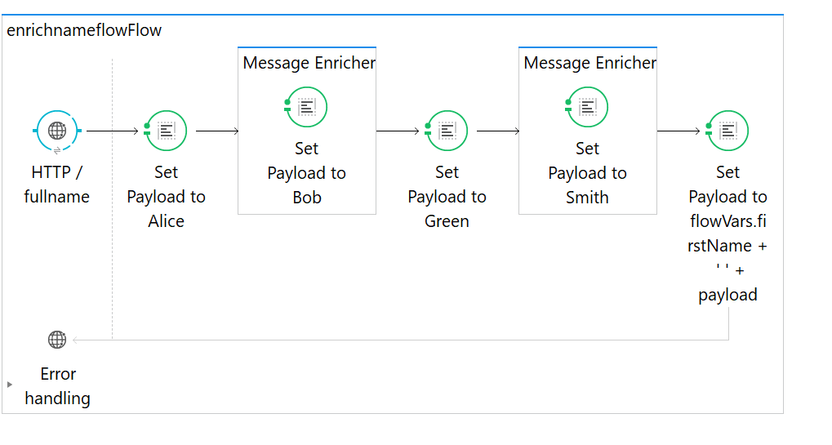

<http:listener-config name=*"HTTP_Listener_Configuration"* host=*"0.0.0.0"* port=*"8081"* doc:name=*"HTTP Listener Configuration"*/>

<flow name=*"enrichnameflowFlow"*>

<http:listener config-ref=*"HTTP_Listener_Configuration"* path=*"/fullname"* doc:name=*"HTTP /fullname"*/>

<set-payload value=*"#['Alice']"* doc:name=*"Set Payload to Alice"*/>

<enricher doc:name=*"Message Enricher"* target=*"#[flowVars.firstName]"*>

<set-payload value=*"#['Bob']"* doc:name=*"Set Payload to Bob"*/>

</enricher>

<set-payload value=*"#['Green']"* doc:name=*"Set Payload to Green"*/>

<enricher doc:name=*"Message Enricher"* target=*"#[flowVars.lastName]"*>

<set-payload value=*"#['Smith']"* doc:name=*"Set Payload to Smith"*/>

</enricher>

<set-payload doc:name=*"Set Payload to flowVars.firstName + ' ' + payload"* value=*"#[flowVars.firstName + ' ' + payload]"*/>

</flow>

* 1. Bob Smith
  2. Alice Green
  3. Alice Smith
  4. Bob Green

1. Refer to the exhibits. The two Mule configuration files belong to the same Mule project. Each HTTP Listener is configured with the same host string and the port number, path, and operation values are shown in the display names.

What is the minimum number of global elements that must be defined to support all these HTTP Listeners?

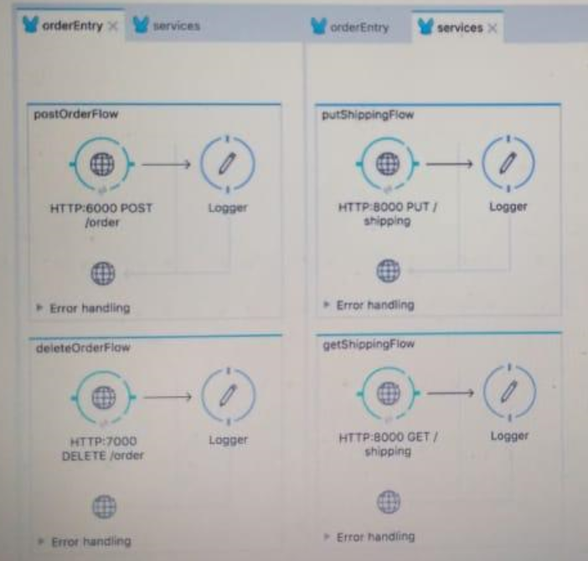

* 1. 1
  2. 2
  3. 3
  4. 4